**Exploring Crime Data in**

**Los Angeles**

**Wesley Stanis**

Los Angeles is a city that for the most part, has its fair share of crime. The year 2020 was definitely an unconventional year, and the crime rates paralleled this oddity.

In this report we explored some of the crimes in Los Angeles for the year of 2020. We began by visualizing and mapping the crimes. We proceeded to explore certain types of crimes with ages and times they occurred. We finally built a couple of models to see if we can get any insights that may lead to predictors on a crime or a time category.

**DATASET**

The dataset contains every crime report from January 1, 2020 to March 10, 2021 from the city of Los Angeles. It was obtained from data.lacity.org

<https://data.lacity.org/Public-Safety/Crime-Data-from-2020-to-Present/2nrs-mtv8>

The dataset contained over 228,000 observations with 28 original variables. Many of these variables were not used, but some of the ones that were used commonly contain time of the crime, the description of the crime, the age of the victim, the sex of the victim, a weapon description, and the latitude and longitude coordinates of the crime. There were a couple of variables created based on conditions in the data, which were time category, and whether there was a weapon. The time categories split the time up into six timeframes.

Plenty of dataframe subsets were created as needed when working with this dataset.

**ANALYSIS**

To get an insight of what types of crimes are in this dataset, obtained a frequency count of words in the crime descriptions and build a couple of wordclouds to visualize them.





We see assault, vehicle and theft has large frequencies in this dataset. The larger words in these wordclouds equates to that word having a higher frequency in the dataset.

We then started by just visualizing all the crimes spread out on a map. We looked at the crimes by age and gender if it was known.

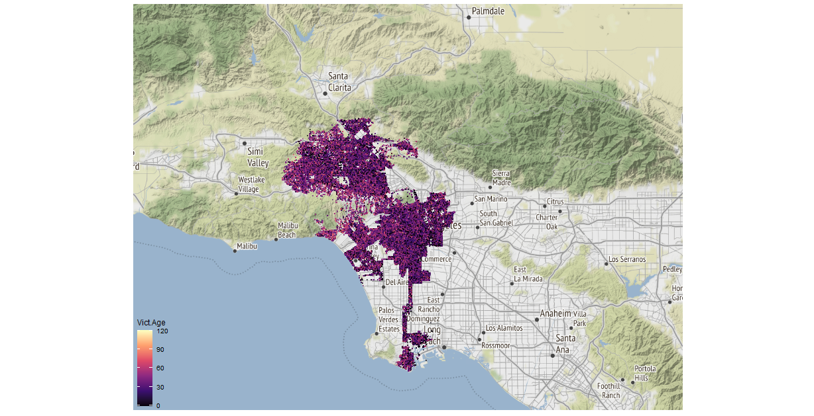

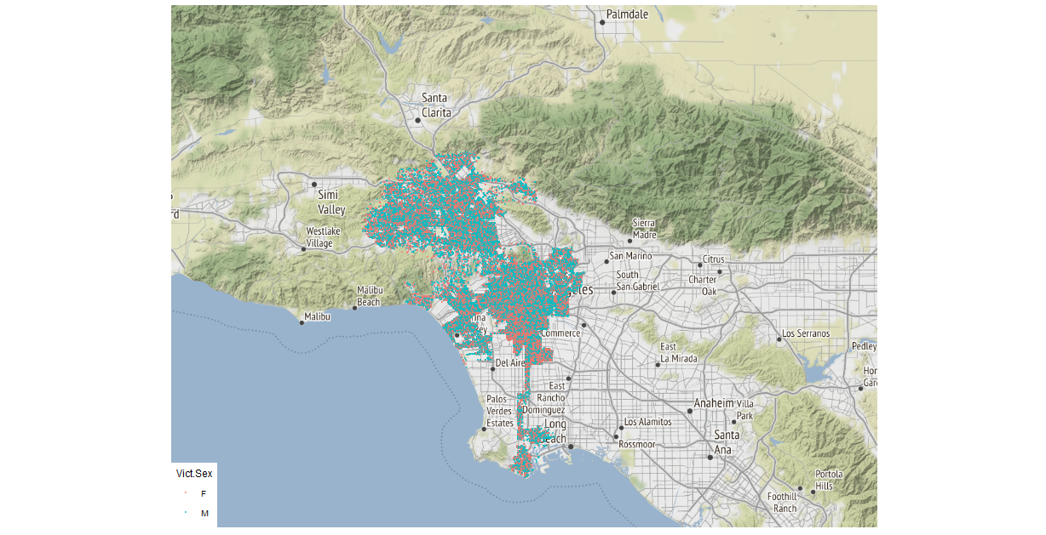

It seems very difficult to find any patterns with either of these two maps, but we can clearly see geographical boundaries that this dataset contains. We can also see that there are plenty of victims that were at a noticeably young age, which we may want to look into.

We then decided to look deeper into a handful of certain crimes. This first section of maps contains aggravated assault and deadly weapon crimes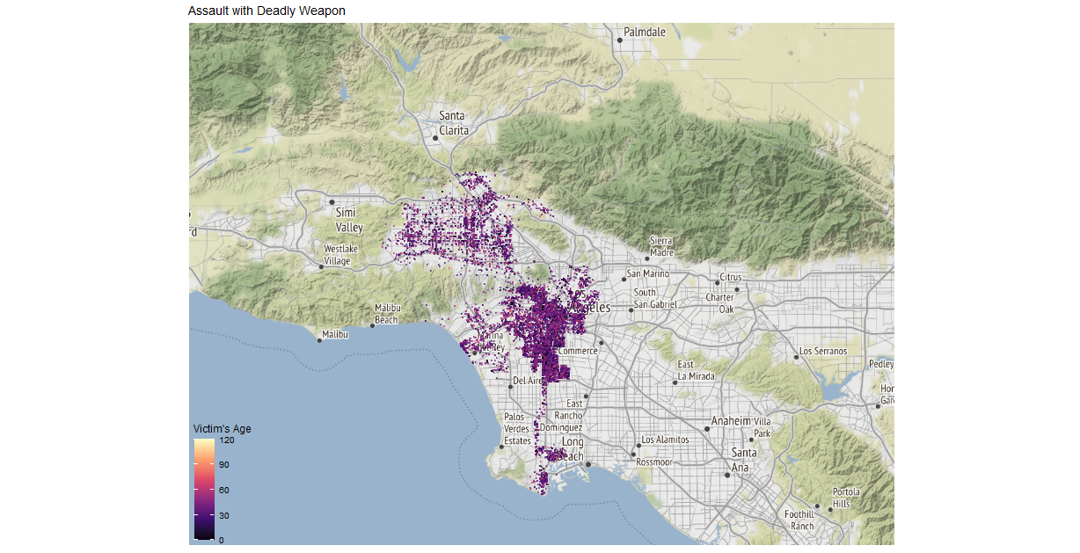

This looks a little spread out as well, although it appears that the crimes are concentrated near downtown. We then zoomed in on that area.

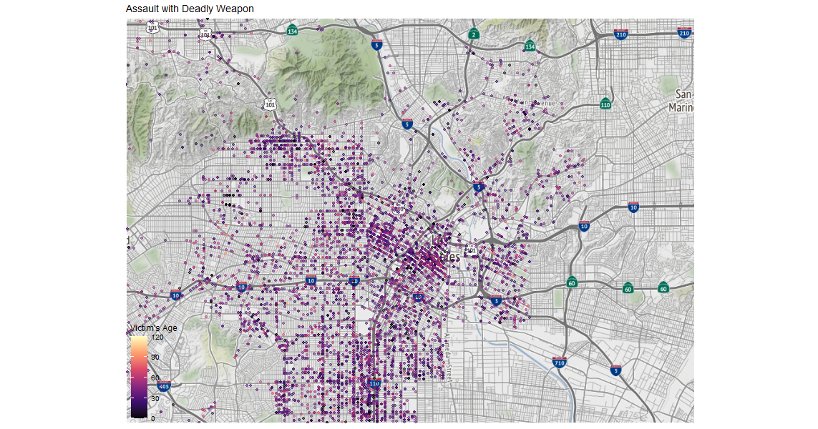

This does not really show us any patterns as well. We can notice that there are plenty of very young victims of this crime. Next, we looked in this specific crime by gender in the downtown area.

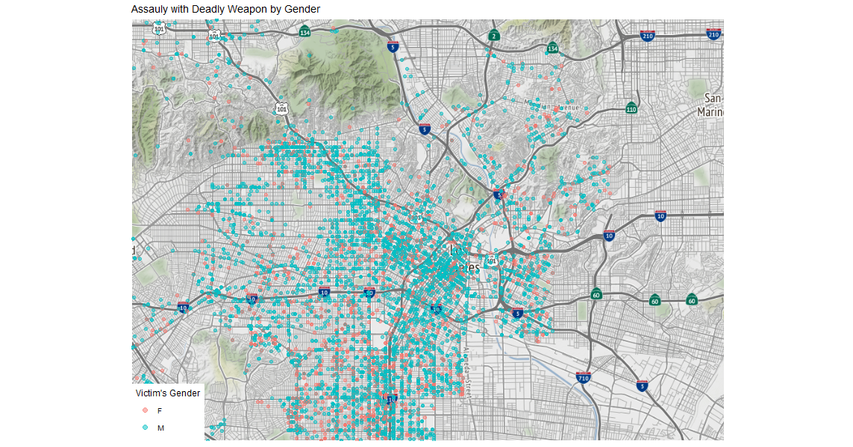

Here we can see that it looks like there are more male victims than female in the downtown area, regarding this aggravated assault/deadly weapon crime. Again, there are not much other significant looking patterns in this map.

One thing we can notice by looking at these two maps is that there does appear to be a slightly higher concentration of this crime somewhat near the 101 and the 110 freeways. The 10 and 5 freeways appear to show a much less concentration.

We proceeded to map out crimes of homicides, theft, burglaries, and stolen vehicles. We first looked at the entire map of these crimes. After noticing a concentration again near downtown on some of these, we then zoomed into the downtown area.

Here we are going to show the maps of all the other selected crimes of interest:

**Homicides**

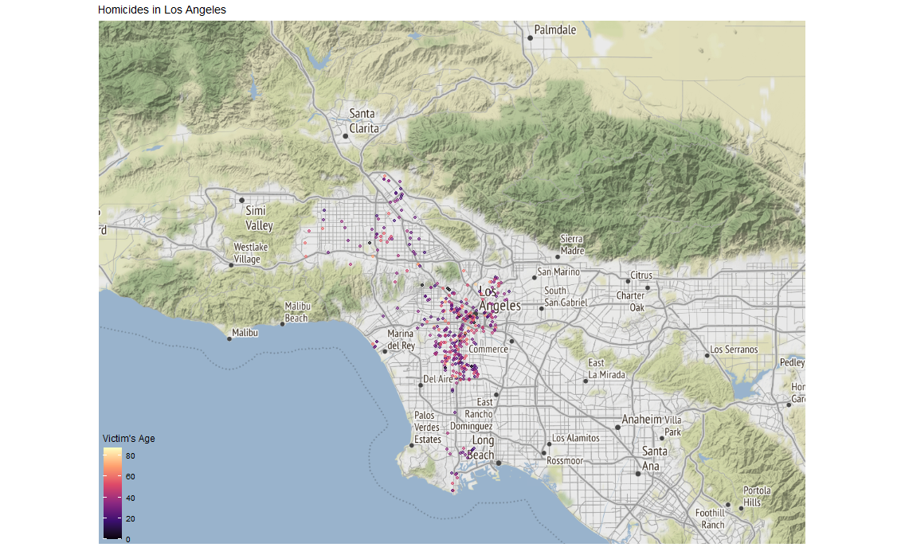

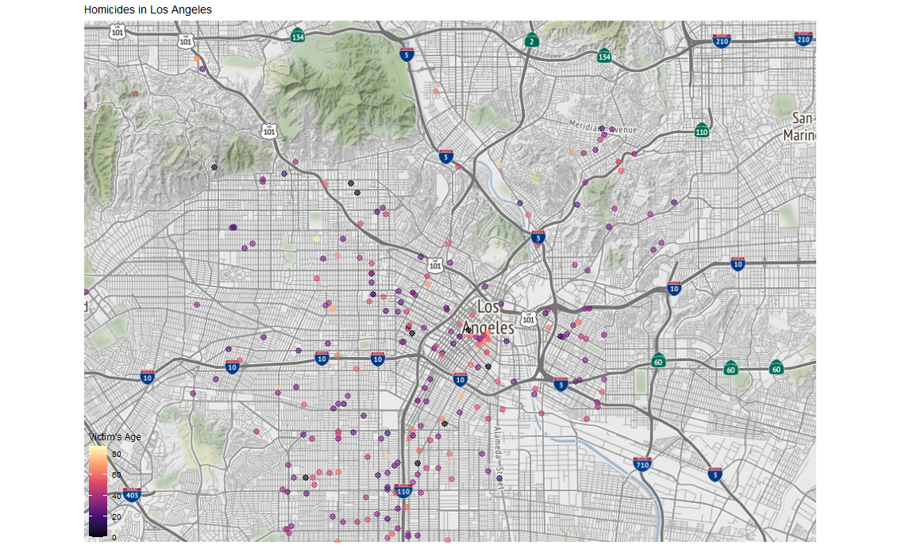

**Theft**

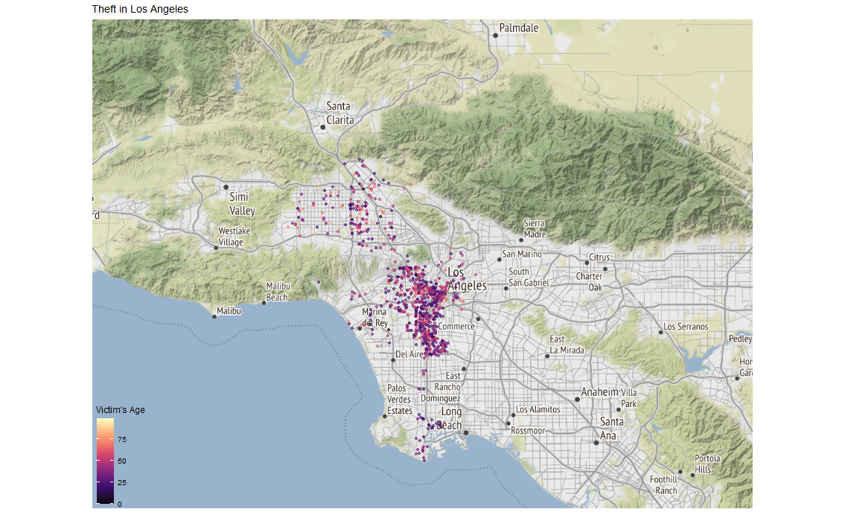

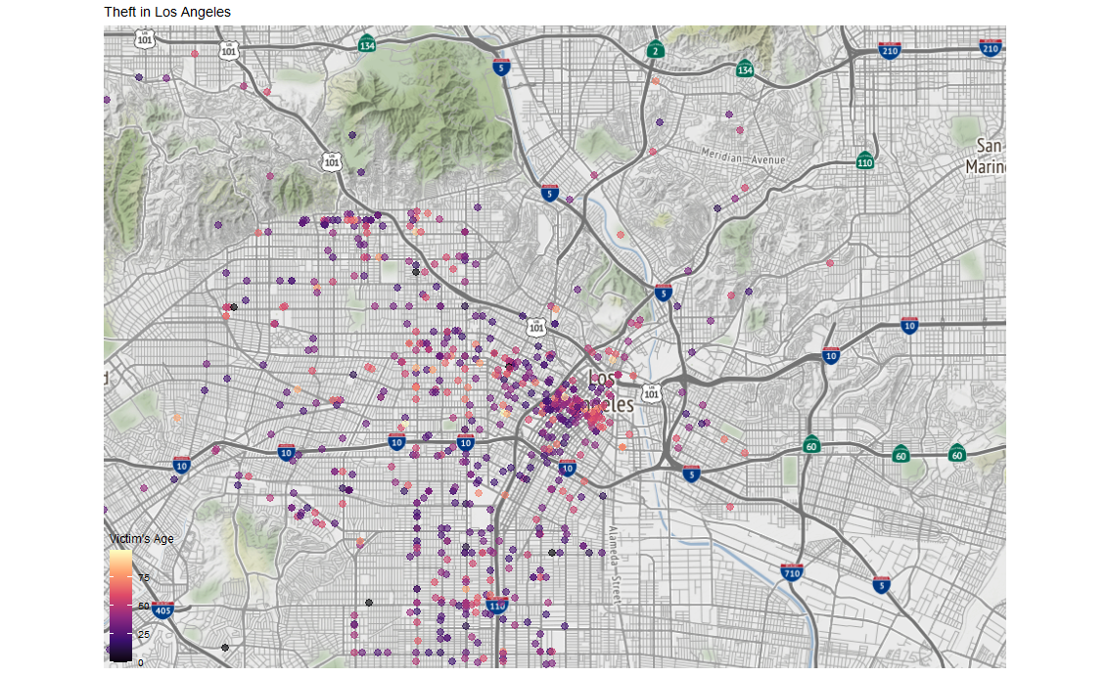

**Burglary**

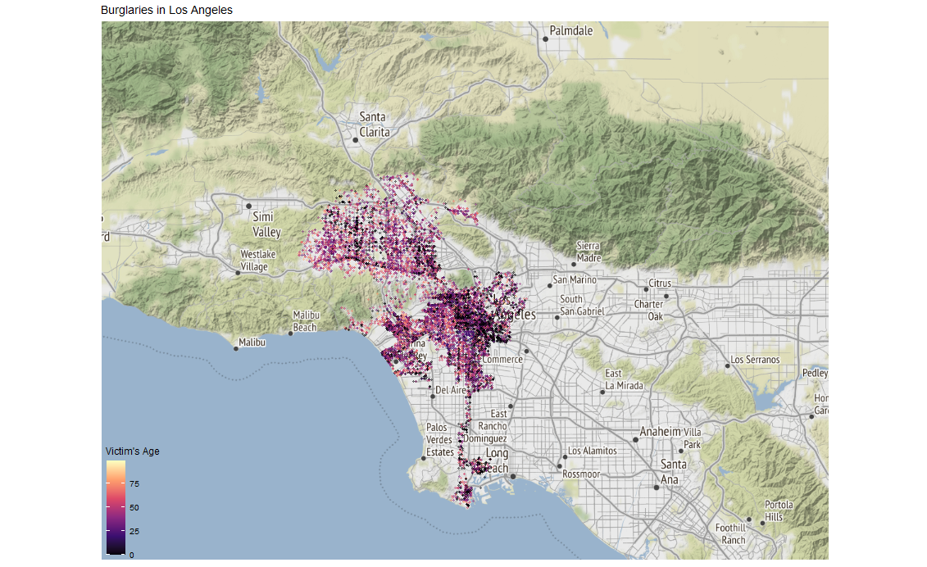

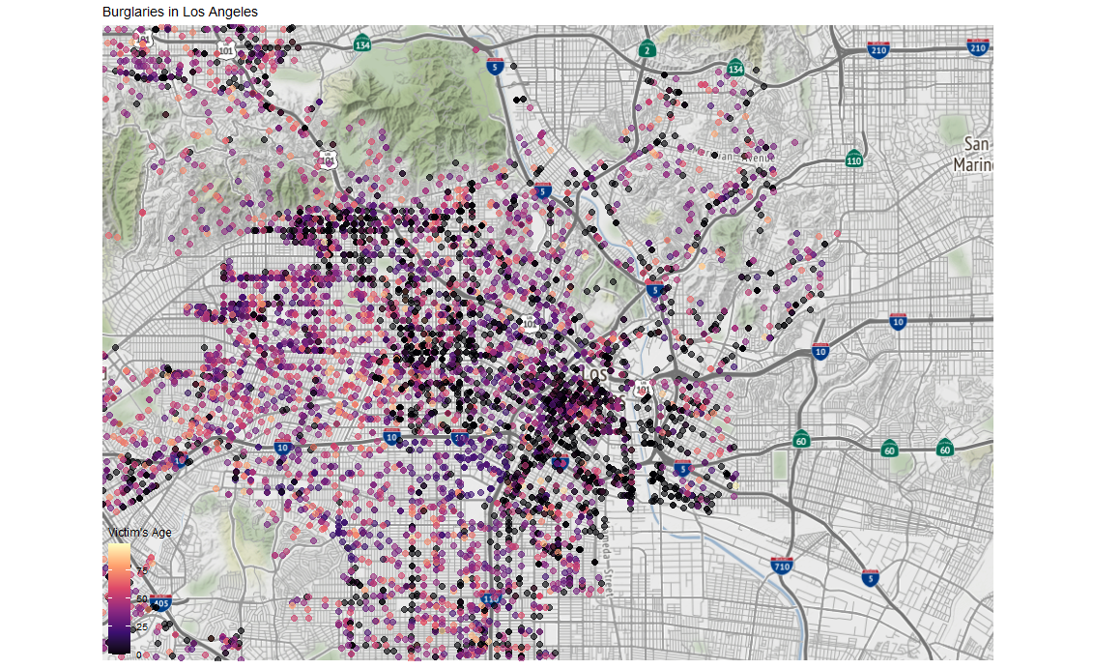

**Stolen Vehicle**

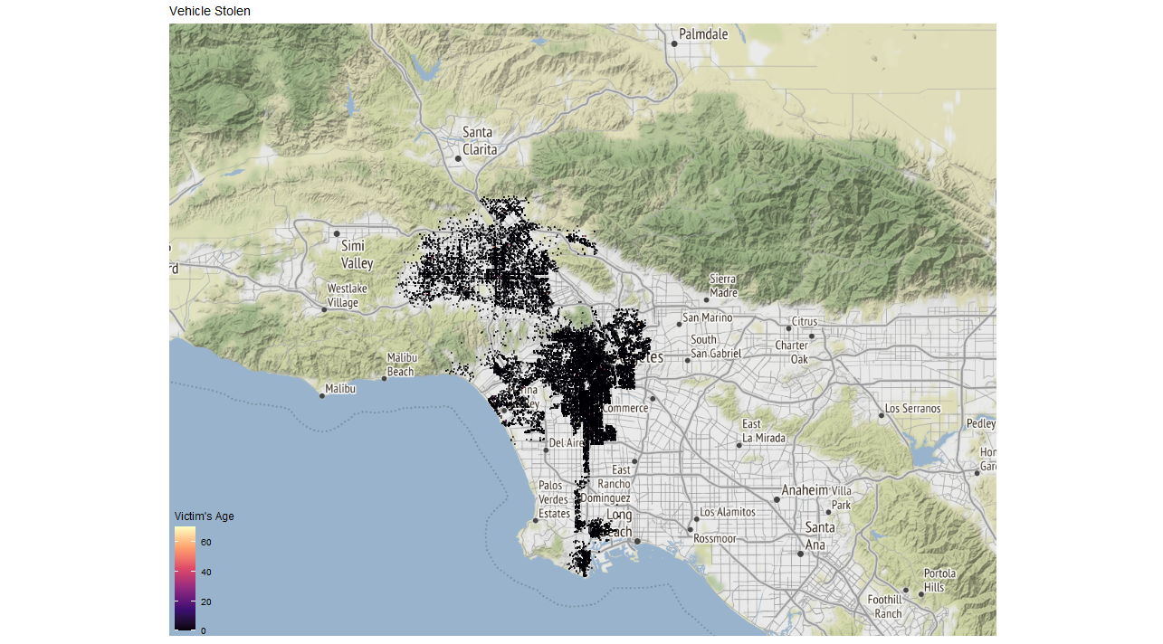

The homicides and theft maps show that the downtown area definitely had some concentration. We can even see that there was a small cluster of homicides downtown that involved much older victims. There was even a larger cluster in that area regarding theft.

It appears that the eastern part of downtown had much older victims of theft, while the western part had relatively younger victims. There did not appear to be any noticeable concentration near the freeways as the aggravated assault crimes had.

The burglary map was very spread out and appeared to have many victims recorded near the age of 0. It looked like the largest cluster of the victims at this age were near downtown.

The stolen vehicle map led to some concern as every victim appeared to be around the age of 0. This led to some more investigating of victims at this early age.

We started by looking at a barplot of all of the crimes where the age of the victim was 0.

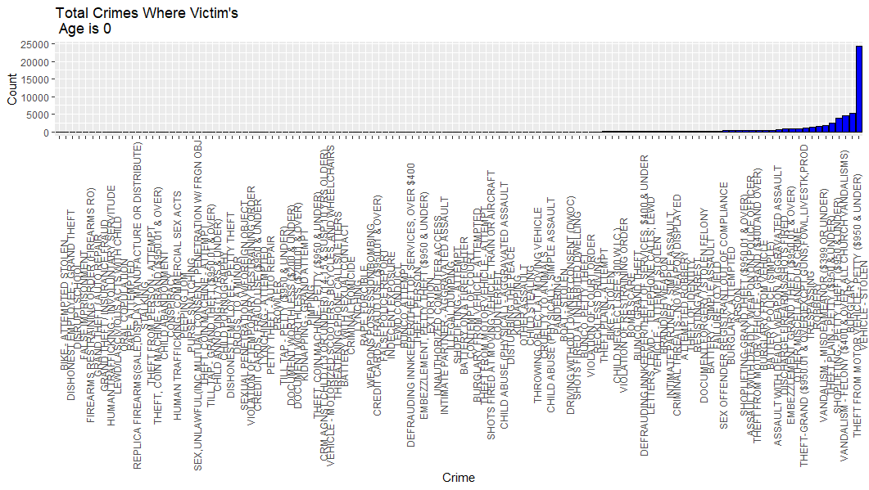

Here we already can see we only want to focus on crimes with the top frequencies.

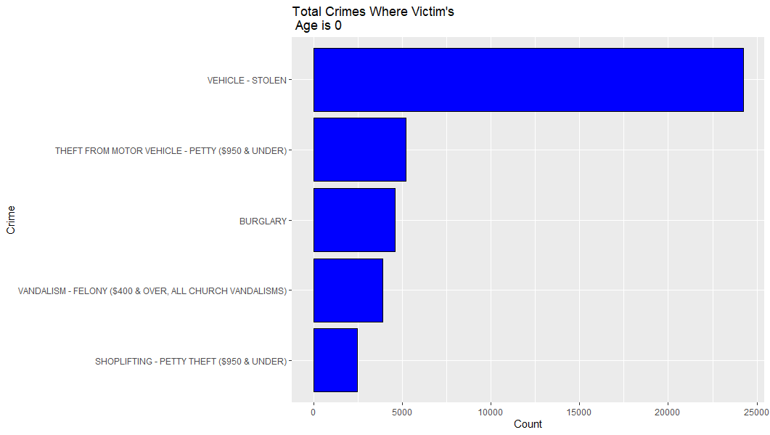

Here we see the top five crimes where the victim was 0 years old. There could be a few reasons why this happened. These types of crimes were against what appears as properties of victims. One possible reason why this may have happened could be that these properties were owned by multiple people, and by default the city marked the age to 0. We can definitely see that these crimes involved properties/materials and did not appear to involve people.

After viewing this we wanted to explore stolen vehicles a little more. We looked into how many stolen vehicle crimes there were compared to how many there were with the victim’s age at 0. Out of 24,284 crimes reported, only 64 were not at the age of 0.

We next wanted to build a random forest model to see if we can classify a stolen vehicle based on some of the attributes of this dataset.

We started by selecting only the variables we were interested in and sampling from the dataset for our model. We randomly sampled 20,000 observations in order to efficiently produce a model while putting an ease on compute power. The variables of interest included the time, the area, the age, the gender, the time category, and whether there was a weapon involved. We then split the data into a training and testing set that consisted of 60% training and 40% testing.

After building our random forest model, we compared our predicted values to out test set in order to distinguish how well this model performed. We calculated an error of 2.7 %.

This looks pretty good. We then plotted a confusion matrix of our predicted values to the real values.

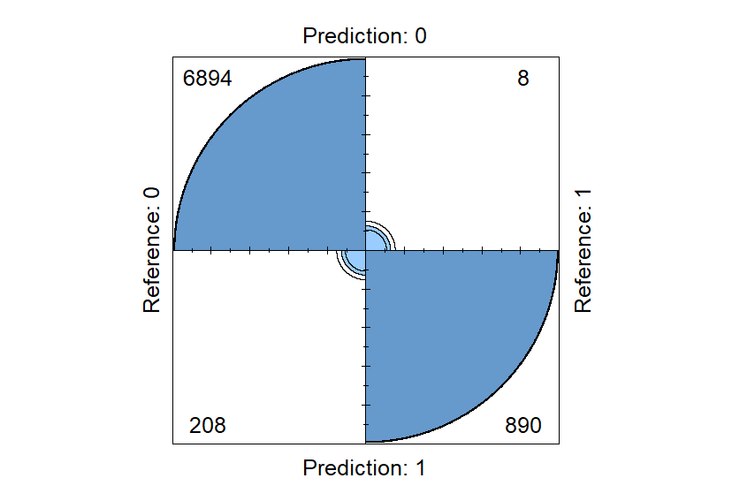

There were 208 instances where the model predicted a stolen vehicle that were actually did not happen, and 8 instances where there was a stolen vehicle, and our model did not predict it. Overall, this was a good model.

We then continued to discover insights of stolen vehicles by building a logistic regression model. We started by only using one variable at a time, and then combining them to compare the results.

The first model used only the time of the crime. The second used area. The third model used the age. The fourth used the gender, and the fifth combined them all. We calculated the ROC curves for each model by comparing the fitted values from the model to the known truths within the data.

Here is a graph of the results:

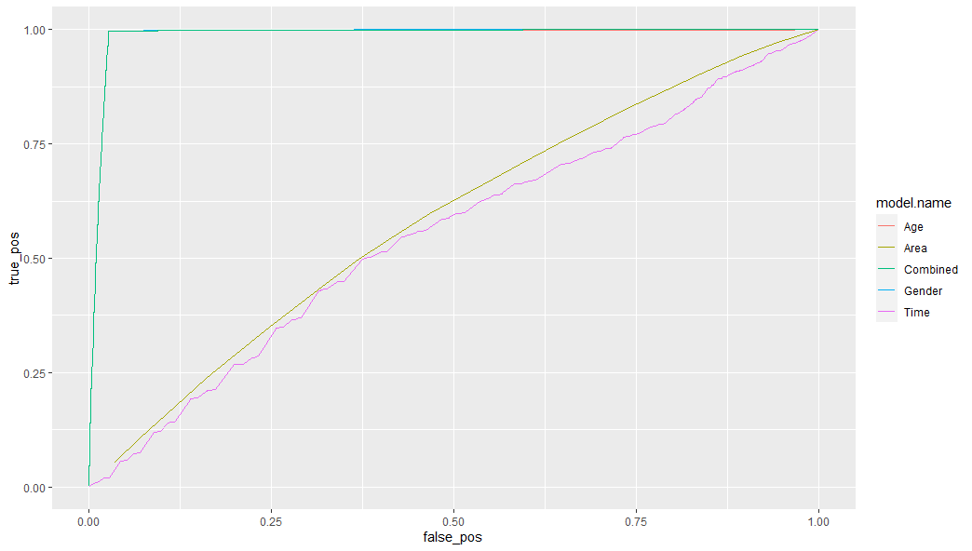

Here we want to stay as close as we can to the left (true positive) portion of the graph. We noticed that combined, age and gender were almost the same, and all the other variables did not perform well in this model. We can assume that the reported gender and age were the driving force in the combined model, and those variables are significant to stolen vehicles.

We then furthered our analysis to investigate the crimes by the time frames of when they were committed.

As stated, we separated the times into six categories, then looked at the number of crimes within these time periods of the day. There is a variable containing the time the crime occurred, and we used this to create our categories. We started by viewing a barplot of all the crimes for each time frame.

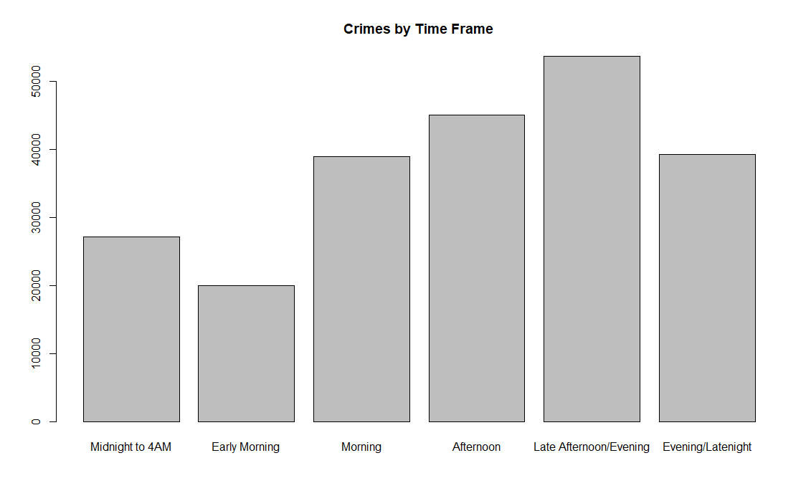

Here were all of the crimes separated by time frames. We can see that the time period that contained the highest number of crimes was the afternoon and evening times. The morning times had lower counts.

After looking at this we created more plots that contained specific types of crimes. We continued to focus on the same crimes that were explored prior in the analysis.

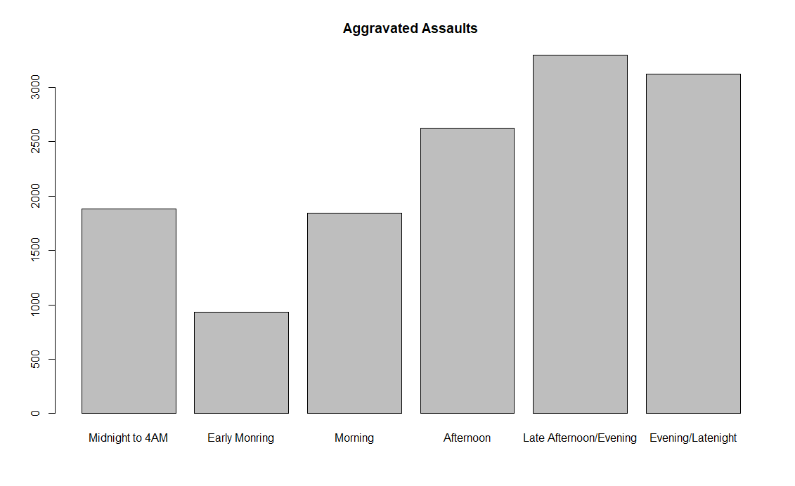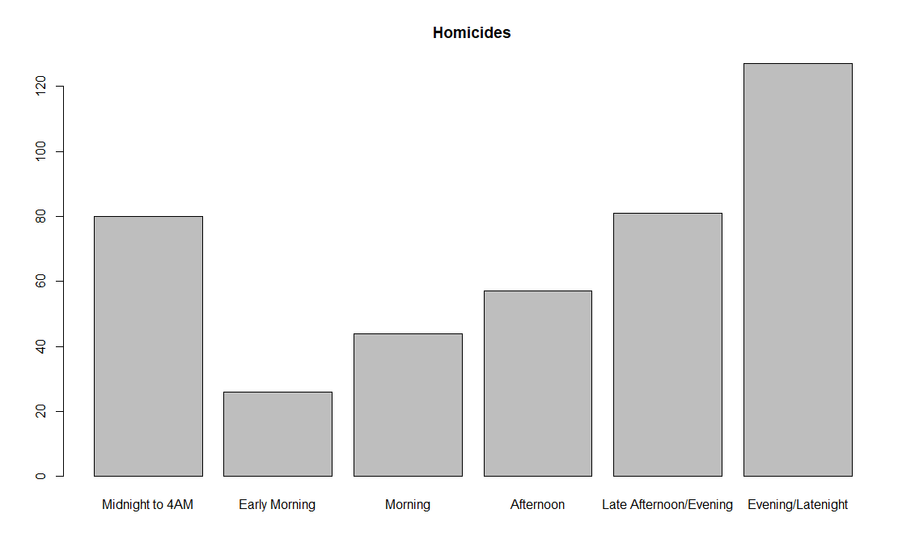

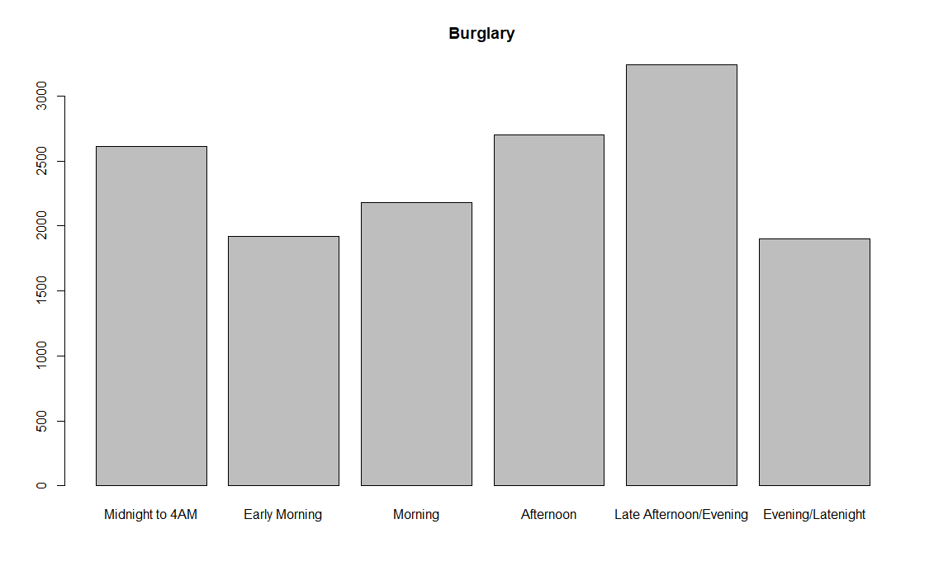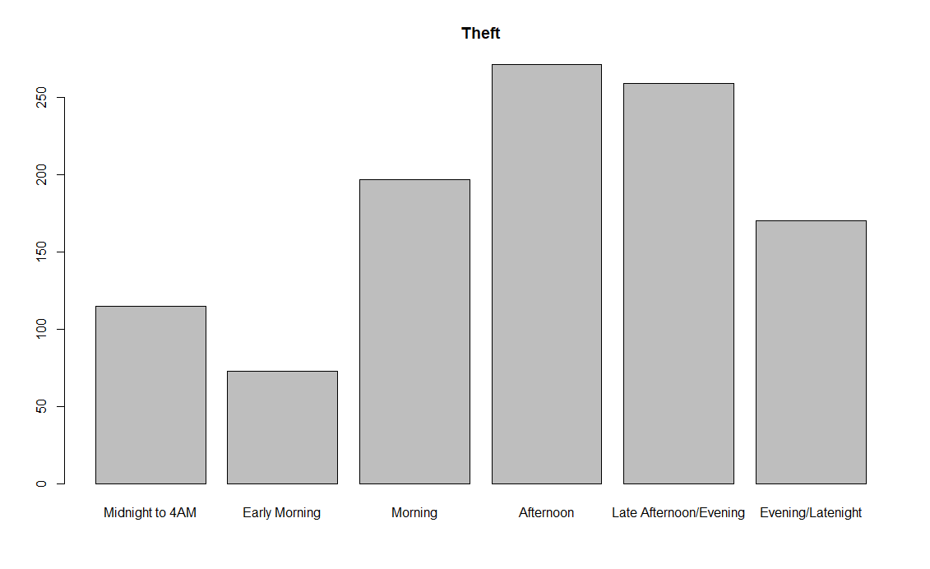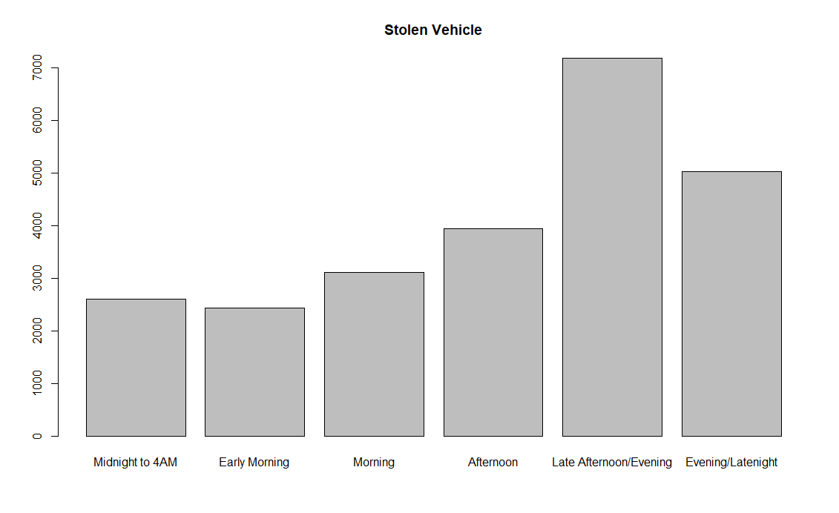

What we can notice here is that the more violent crimes had a higher proportion at night, while the property crimes appeared to peak more in the afternoon.

The one common aspect these graphs show us is that it seems like the time period with fewest crimes is the early morning, which is from 4:00AM to 8:00AM. Burglary was the only crime here that had the proportion of their crimes in that category to be about the same as another, while the rest of the crimes had the early morning containing the lowest counts of recorded crimes.

To further this investigation we created more maps, but focused on the crimes at these timeframes.

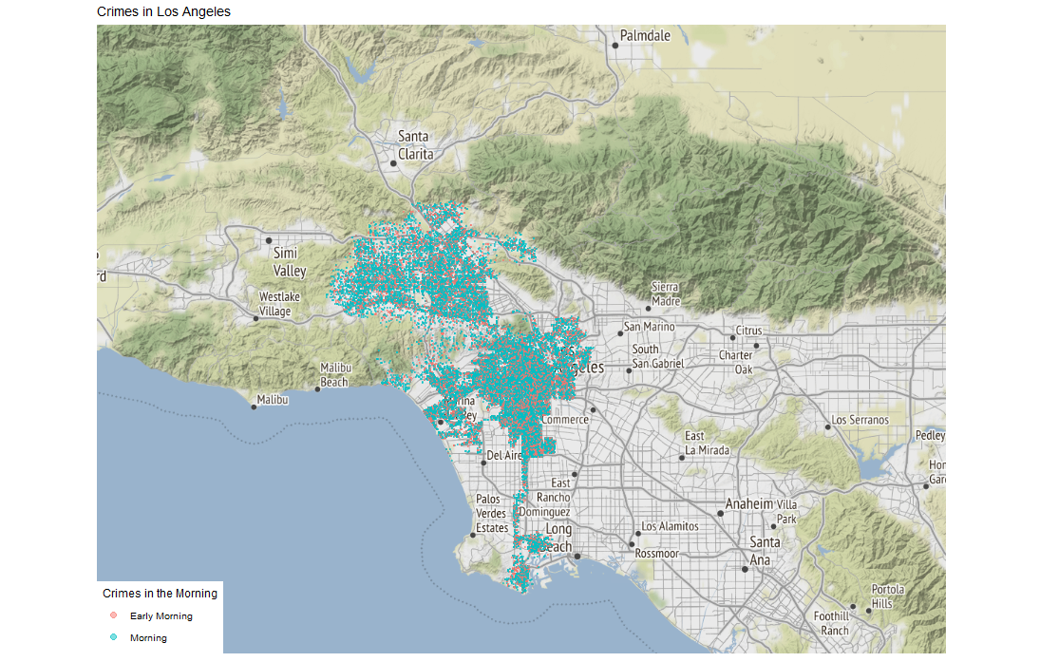

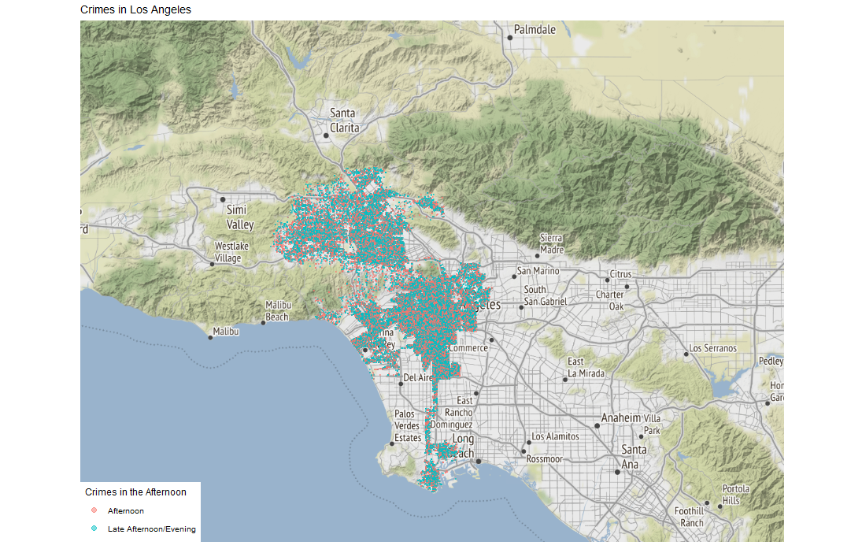

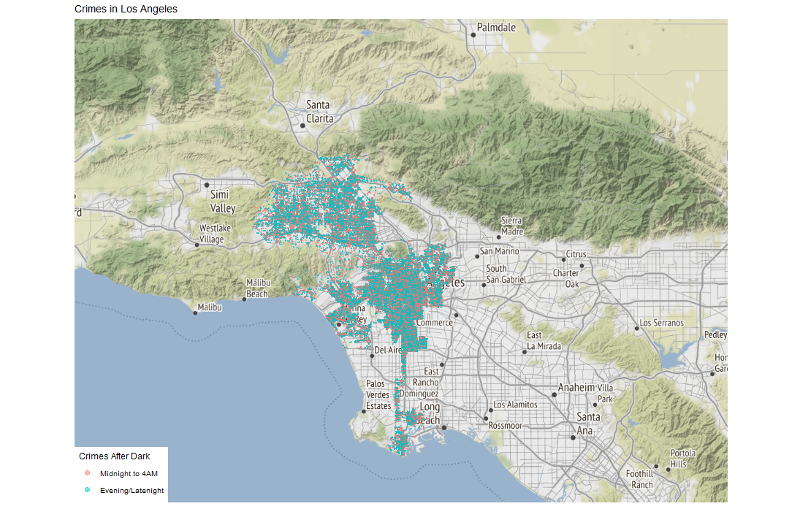

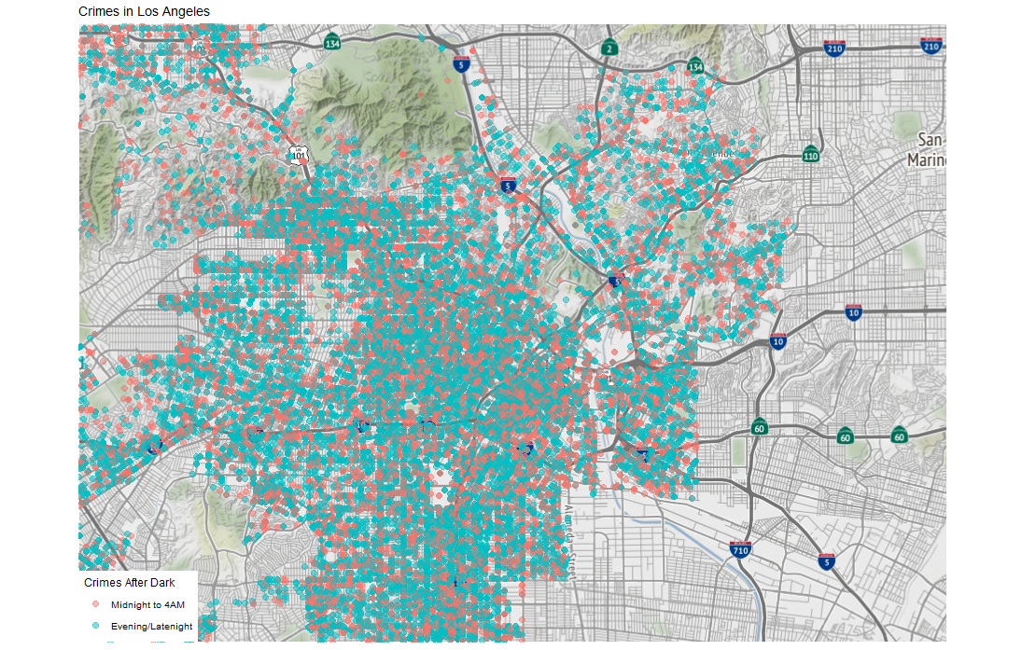

Here we don’t see any particular pattern, although the morning and night times appear to have a slightly higher concentration near the downtown area.

The final analysis we wanted to do was to compare whether there is a difference in the victim’s age, by each time category. We first found the means of the age for each category.

|  |  |
| --- | --- |
| **Time Category** | **Mean Age** |
| Midnight to 4AM | 28.9 |
| Early Morning | 29.86 |
| Morning | 32.74 |
| Afternoon | 31.04 |
| Late Afternoon/Evening | 28.58 |
| Evening/Latenight | 28.11 |

From looking at this, it looks like the morning and afternoon had a slightly older average age of the victim.

We then build a Bayesian anova model to check if there is a true difference in the means. This model used a Markov Chain Monte Carlo method, which generated 50,000 simulations to approximate the posterior distributions of these categories.

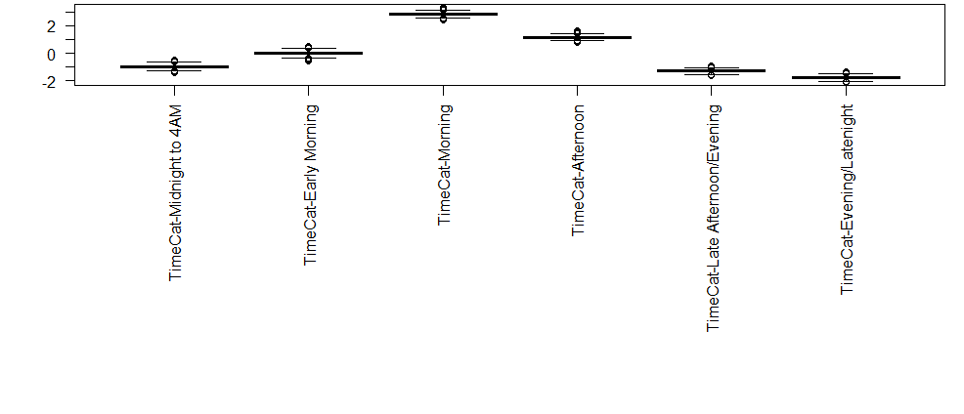

By looking at this chart alone we can see there is a difference in the morning and afternoon timeframes compared to the late night and midnight timeframes. It appears that the evening, late night, midnight to 4AM, and possibly even the early morning categories are all similar, while the morning and afternoon are far above. This gives us evidence that there is a difference in mean age of a victim when it comes to the morning, day, and night. When comparing these groups together, we can assume that the mean difference is not due to random sampling error.

**KEY INSIGHTS / FURTHER INVESTIGATION**

One key insight to consider from this analysis is that it appears property crimes and violent crimes have different attributes. They seem to have peaks and lows at different times throughout the day, and even how they are recorded can be different. This appears only true when comparing the specific crimes added in this analysis. We can re-run this analysis with many different types of crimes, and it may very our results, but for the crimes we focused on, there is a difference. Regarding the time, we can also recognize that there is a difference in the average age of a victim depending on the time of day.

When it pertains to a stolen vehicle, we can see that the reported age and gender are the driving forces when it comes to building a predictive model. I need to emphasize “reported” when it comes to this, as we saw most stolen vehicle victim’s age was recorded as 0. There were not much significant patterns discovered in the maps other than a few pockets of clustered data in the downtown area regarding their age, and a slightly higher concentration of aggravated assault with weapon crimes in the proximity of a couple of highways.

A further investigation with this data may be to explore some different crimes. We can build a model focused around a different crime like we did with stolen vehicle, and it may give some better insights due to the age not being a suspected default value.